#### Cardiologic examination report

|  |  |
| --- | --- |
| καρτα2 | Exam date : 1.07.2019 **---**  **Ms. Karin Schiller**  **« mr Grey»**  Aegean breed,  male, 7 kg  Age: 3 yo |

**Dr. Theodoros SINANIS**

DVM, MSc, MRCVS

*Master of Science in Veterinary Internal Medicine,*

*Specially trained in Veterinary Cardiology at the*

*Cardiology Unit of Alfort,Paris- France*

*(École Nationale Vétérinaire d'Alfort)*

*European Society of Veterinary Cardiology member*

** Medical history – clinical examination**

**History :**

* Referring physician : **Dr. Margarita Valvi.**
* Cardiologic examination in account of previous hypertrophic cardiomyopathy diagnosis (March 2018)
* The cat presents easy fatigue & dyspnea.
* He is in a good general status and has a relatively good appetite.
* Radiographic examination: ND
* Cardiac medication so far: **Imidaprile** po

**Clinical findings** :

* Cardiac auscultation was unremarkable.
* Normal femoral pulse.
* Lung auscultation was unremarkable.
* No cough reproduction during tracheal palpation.
* Normal mucous membranes.
* Mild dental calculus.
* Normal body weight (BS : 3.5/5).
* Normal peripheral lymph nodes size

 **Echocardiography exam results**

|  |  |  |  |
| --- | --- | --- | --- |
| **Parameters** |  | **Parameters** |  |
| RVDd | 6.7 mm | Ao Vmax | 0.84 m/s |
| IVSd | 8.2 mm | P Vmax | 0.58 m/s |
| LVDd | 12.1 mm | Ant. mitral leaflet | - mm |
| PWd | 11.9 mm | Post. mitral leaflet | - mm |
| IVSs | 9.4 mm | IVs end-diastole SA | 6,8 mm |
| LVDs | 5 mm | Mitral E/A wave | 1.31/0.36 (3.6) 58 ms |
| PWs | 15.9 mm | RA/LA | 13.8/14.9 mm |
| FS | 59 % | Mit. Reg. Vmax | - m/s |
| LA- Ao | 24.4 - 8.7 mm | Tric. Reg. Vmax | - m/s |
| LA/Ao | 2.79 | PT/Ao | 1 |

## Interpretation

Περιγραφή: Περιγραφή: ac387 **Right parasternal and transventricular short-axis view (m-mode):**

* Intense thickening of the LV free wall and interventricular wall.
* The contractility of the LV is WNL.
* Normal right ventricular dimensions.

Περιγραφή: Περιγραφή: ac387 **Left atrium examination presents:**

* The left atrial dimensions are notably increased at the end-systole.
* Mild regurgitant volume through the mitral valve, on colour flow Doppler examination.

Περιγραφή: ac387 **Right parasternal and transaortic short-axis view:**

* No anatomic lesions were found at the level of the pulmonary annulus.
* Normal pulmonic flow.
* No pulmonic regurgitation is present.

Περιγραφή: ac387 **Right parasternal long-axis four & five chamber views:**

* Normal mitral valve (anterior & posterior leaflet) appearance, no thickening nor prolapse are depicted.
* Increased right atrial dimensions.
* Decreased right to left atrial ratio (RA/LA=0.7).
* No aortic regurgitation is present.
* No interventricular nor interatrial septal defect was found.

Περιγραφή: ac387 **Left parasternal long-axis four & five chamber views:**

* Turbulent aortic flow at the level of the aortic annulus.
* Transmitral flow velocity indicative of diastolic dysfunction (E>>A wave).
* No tricuspid regurgitation is present on colour-flow Doppler.

Περιγραφή: Περιγραφή: ac387 **Other points:**

* No pericardial nor pleural effusion is present.
* No pulmonary hypertension is present.
* No smoke effect or thrombus detected.
* Ecg findings: isolated ventricular complexes

### Conclusions

* **Hypertrophic cardiomyopathy – non obstructive,** with intense thickening of the LV free wall & the interventricular septum, severe LA dilatationand(?) congestive heart failure (radiography is required for definitive diagnosis of congestion).
* Hypertrophic cardiomyopathy is the most common acquired feline heart disease and appears mostly in older cats, though younger can also be affected. It is characterized by myocardial thickening which may lead to congestive heart failure.
* The prognosis here is cautious because of the severe LA dilatation and the intense myocardial thickening.
* Diuretic treatment should be diminished during the next weeks.
* Some follow up is suggested after 6 months.
  + **Cardiac medication :**

1. **Furosemide** : 2,14 mg/kg po BID
2. **Spironolactone** : 2,8 mg/kg po SID
3. **Benazepril** : 0,35 mg/kg po SID
4. **Pimobendan** : 0,18 mg/kg po BID
5. **Clopidogrel** : 18.75 mg po SID

**Yours sincerely:**

**Dr. Theodoros Sinanis**

[**theodsin@hotmail.com**](mailto:theodsin@hotmail.com)

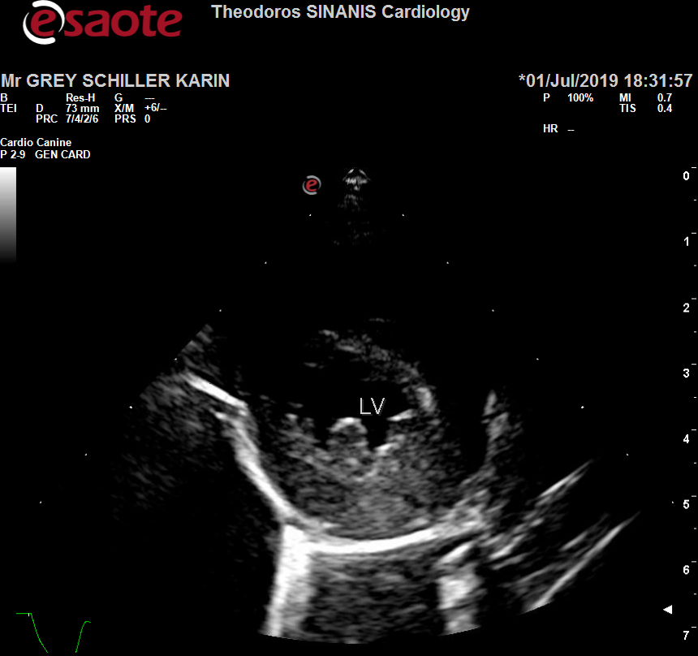 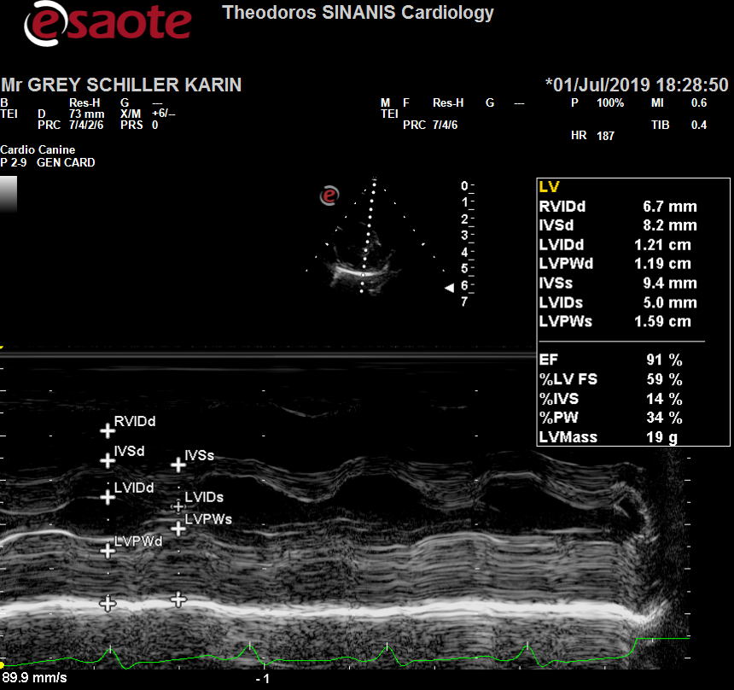

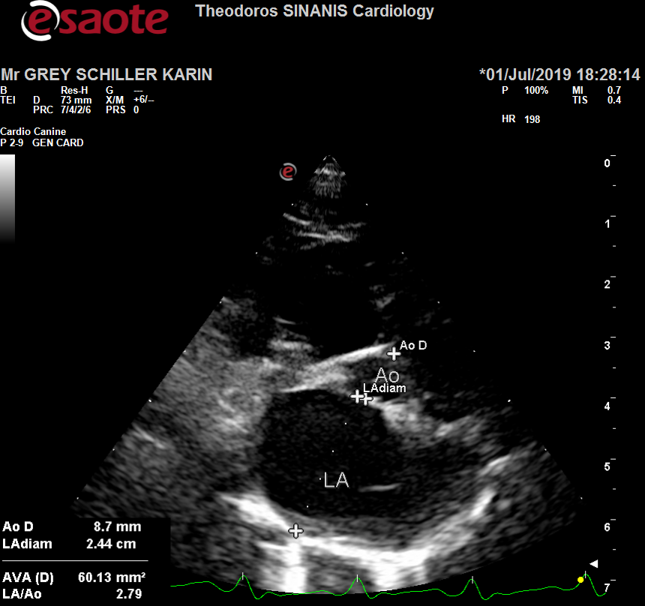 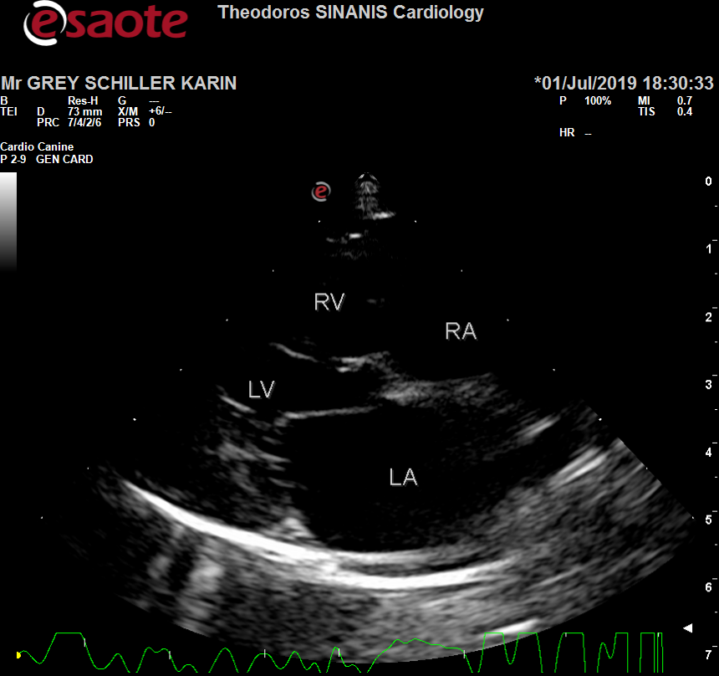

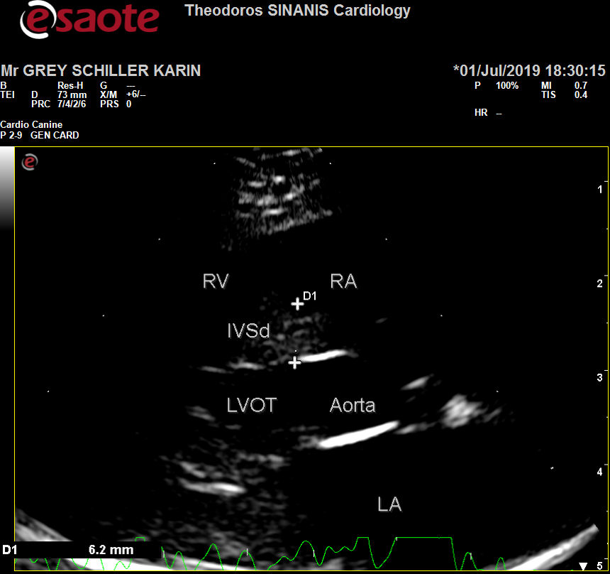 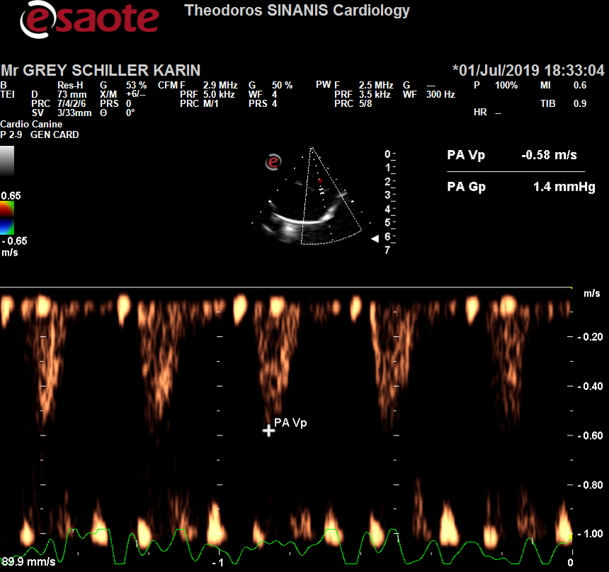

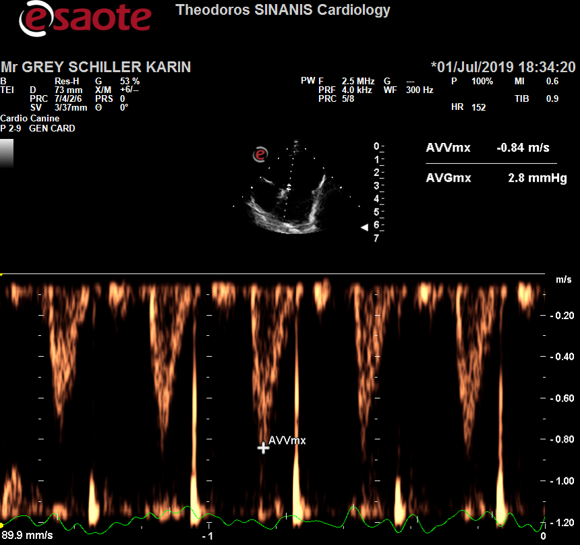

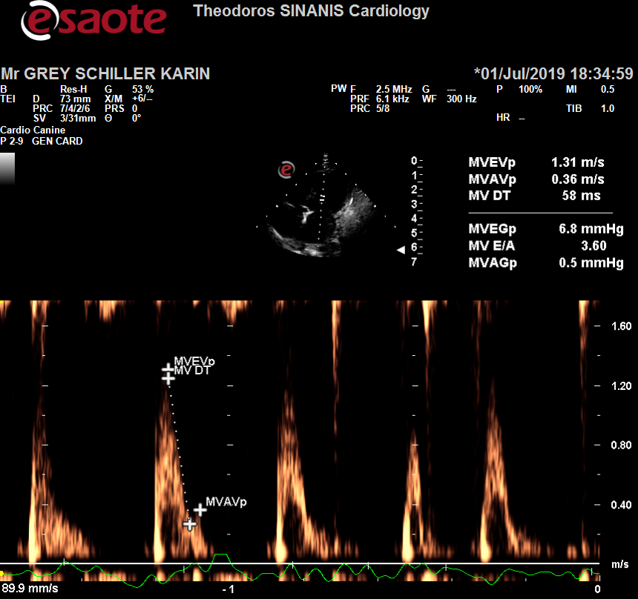

Περιγραφή: Περιγραφή: ac387Περιγραφή: Περιγραφή: ac387